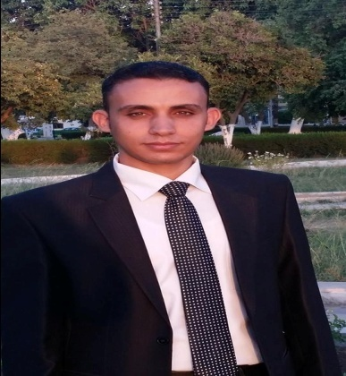

**🖎 LANGUAGES :**

**English : high degree " written and spoken "**

**🖎 COMPUTER SKILLS :**

**Net : General knowledge .**

**Other :,Word .Excel ,Autocad, Sap2000,Arc gis**

**1- work as a team member toward common goals.**

**2- able to work well with all levels of management & people**

* **Name : Romany Hamdy Welson**
* **Address : Assuit-dayrout**
* **Nationality : Egyptian**
* **Birth Place : Assuit**
* **Date Of Birth : 10 / 8 / 1986**
* **Marital Status : Single**
* **Military Service : Finished**
* **Mobile : 01281049822**
* **E-mail : Romany_hamdy@yahoo.com**